OSPF L2 HSRP Integrated Lab

In this lab we will combine L2 redundancy with HSRP and OSPF.
Can be completed with Physical Lab, VIRL or Packet Tracer. GNS3 can’t do the switches.
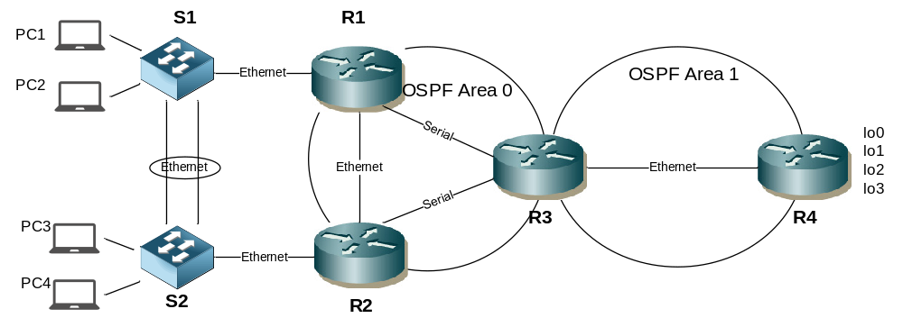

Step 1 - Physical
- Cable up the lab network as per the topology diagram. Note replace Serial with Ethernet links in VIRL
- The routers can be 1841 or 1941 models. Ensure the HWIC-2T (for serial connectivity) is inserted if using packet tracer.
- There is no specification for which end of each serial link should be DCE for serial connections

Step 2 – Configure Layer 2
- Configure S1 & S2 to use Rapid PVST+ spanning tree
- Create 2 new VLANs on S1 &2 as follows
VLAN ID | VLAN NAME
11 | operations
22 | sales

- Configure R1 as the root bridge for both vlans
- Configure etherchannel using LACP for the ethernet links between S1 and S2
- Ensure LACP will actively try to negotiate an etherchannel

- Configure the etherchannel as a Trunk that will only carry VLANs 1,11 & 22
- Ensure the trunk is non negotiable
- Change the etherchannel loadbalancing to use destination MAC address
- Configure PC1 & PC3 user ports in VLAN 11
- Configire PC2 & PC4 user ports in VLAN 22
- Ensure all user ports will transition to forwarding immediately.
- Ensure all user ports will shutdown if any BPDUs are received on that port.

Step 3 – Inter VLAN Routing
- Configure inter VLAN routing between R1 & S1 and R2 & S2
- Ensure both routers can route traffic to both VLANs 11 & 22
- Configure R1 and R2 LAN addressing as follows
R1 LAN – VLAN 11 | 192.168.11.1/24
R1 LAN – VLAN 22 | 192.168.22.1/24
R2 LAN – VLAN 11 | 192.168.11.2/24
R2 LAN – VLAN 22 | 192.168.22.2/24

Step 4 – HSRP
- Configure an HSRP standby group on R1 and R3 for both VLANs as per the following table

Group | VIP | Priority R1 | Priority R2
For VLAN 11 | 192.168.11.3/24 | 105 | 100 (default)
For VLAN 22 | 192.168.22.3/24 | 100 (default) | 105

- Ensure the routers can preemptively take control if they have a higher priority
- Ensure that HSRP tracks the state of the serial interface on R1 and R2 and will decrement the standby priority by 10 (default) if it goes down

Step 5 – Configure PCs (note – use an IOSv node in VIRL to simulate end PC, be aware of memory limitations. It may not be possible to have 4 devices)
- Configure PC IP addresses, mask and default gateway as per the router LAN network and VLAN information above.
- You can choose the IP address to assign to each PC
- Test that each PC can ping its default gateway and that PCs from different VLANs can ping each other

Step 6 – Configure Router interfaces
- Configure the correct end of the serial links with clocking (not required in VIRL)
- Configure router WAN IP addresses as per the table and activate the links

R1 – R2 Ethernet | 172.16.12.0/30
R1 – R3 Serial | 172.16.13.0/30
R2 – R3 Serial | 172.16.23.0/30
R3 – R4 Ethernet | 172.16.34.0/30

- Test each link

Step 7 – Configure OSPF
- Configure OSPF router IDs in the format of x.x.x.x where x = the router number
- Ensure that OSPF can calculate costs for gigabit links less than 100mb
- Ensure R1 is elected DR for the multi access LAN segment between R1 and R2
- Ensure R3 is elected DR for the multi access LAN segment between R3 and R4
- Activate OSPF on router interfaces for the correct Areas as per the table

R1 – R2 Ethernet | Area 0
R1 – R3 Serial | Area 0
R2 – R3 Serial | Area 0
R3 – R4 Serial | Area 1

- Configure Area 1 as a stub area
- Configure MD5 interface authentication between R3 & R4 (password = cisco)
- Advertise R1 & R2 links to S1 & S2 as OSPF internal routes but do not send or receive OSPF hello or LSA packets over these links

Step 8 – Redistribution and summarisation
- Configure the following loopback interfaces on R4

lo0 | 100.4.4.1/24
lo1 | 100.4.1.4/24
lo2 | 100.4.2.4/24
lo3 | 100.4.3.4/24

- Advertise the loopback networks into OSPF as internal routes
- Confirm the routes are present in R3s route table
- Summarise the the 4 loopback networks from area 1 into a single route on the ABR
- Confirm summary is present on R1 and R2
- Configure the following static routes on R4

R4(config)#ip route 200.2.0.0 255.255.255.0 null 0
R4(config)#ip route 200.2.1.0 255.255.255.0 null 0

- Redistribute the statics into OSPF with a static cost of 25
- Confirm the routes are present in R3s route table

Step 9 – Testing
- Test that each PC can ping each loopback interface on R4
- Confirm the path taken from each PC to the lo0 on R4 and back again

Challenge
- How could you ensure the loopback networks are advertised into OSPF as /24 and not /32 ?

